**Question 1: Write a program that will compare the averages of two double arrays.**

//summary: This program takes in values for two arrays, finds the average for both, and tells the user

//which average is higher.

//name: Jenna Wolf

//class: Computer Science II, CS-265

//instructor: Mr. Waleed Amer

//date: 01/22/2023

import java.util.Scanner; //allows inputs to be made

public class Main {

public static void main(String[] args) {

Scanner input = new Scanner(System.in); //names the input

double[] listOne = new double[4]; //holds the listOne data (is an array)

double[] listTwo = new double[4]; //holds the listTwo data (is an array)

//takes in the numbers for listOne

System.out.print("Please input your values for array one: ");

for(int i = 0; i < 4; i++)

listOne[i] = input.nextDouble();

//takes in the numbers for listTwo

System.out.print("Please input your values for array two: ");

for(int i = 0; i < 4; i++)

listTwo[i] = input.nextDouble();

double avg1 = Avg(listOne); //calls the avg method and sets avg1 to the value returned

double avg2 = Avg(listTwo); //calls the avg method and sets avg2 to the value returned

//displays a statement depending on the results of avg1 and avg2

if(avg1 >= avg2)

System.out.println("Average of array 1 greater than or equal to array 2");

else

System.out.println("Average of array 1 is less than array 2");

}

public static double Avg (double [] array) {

double avg = 0; //holds the avg data and sets it to 0

//adds together the values in the array

for(int i = 0; i < 4; i++)

avg += array[i];

avg = avg / 4; //divides the total of the values by 4

return avg; //returns the avg data

}

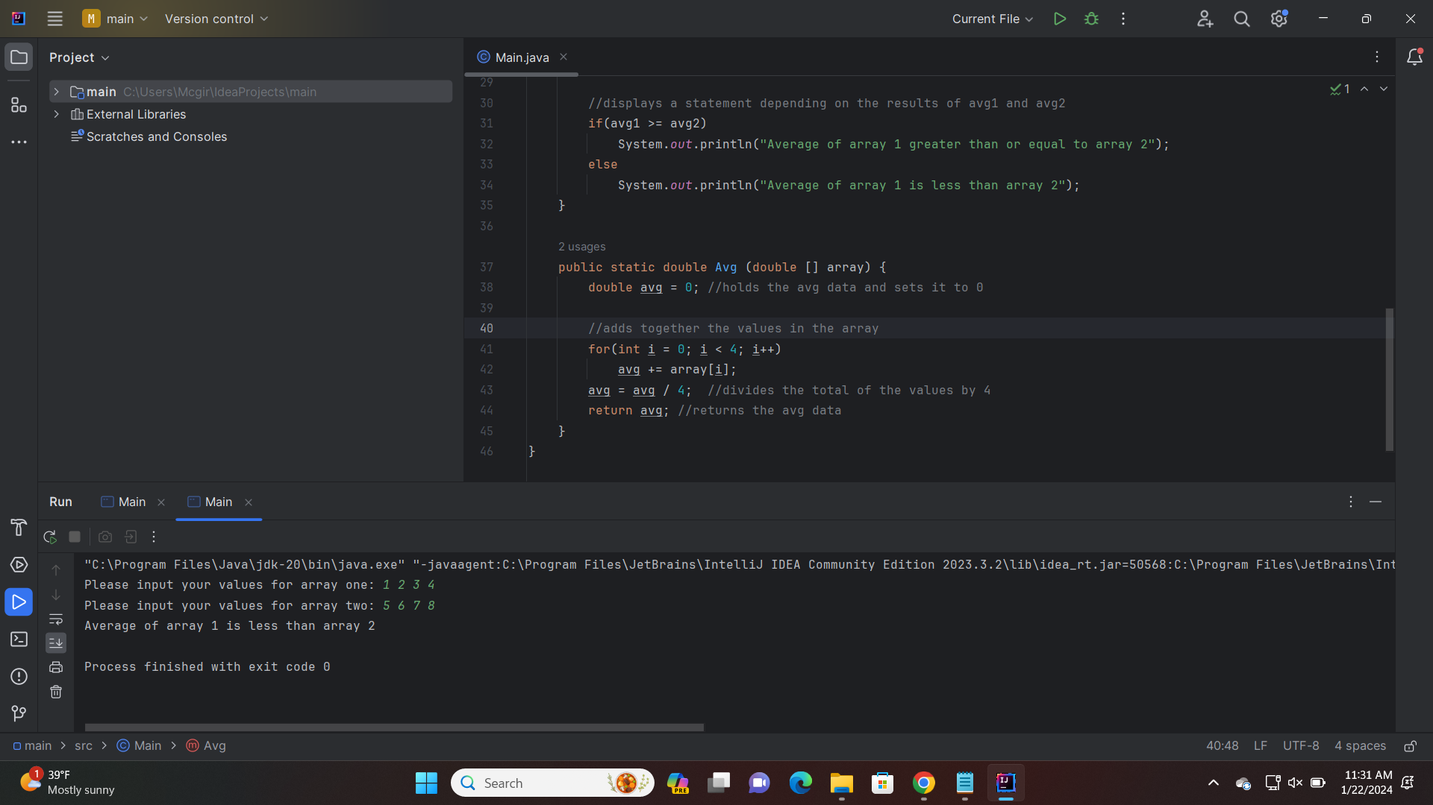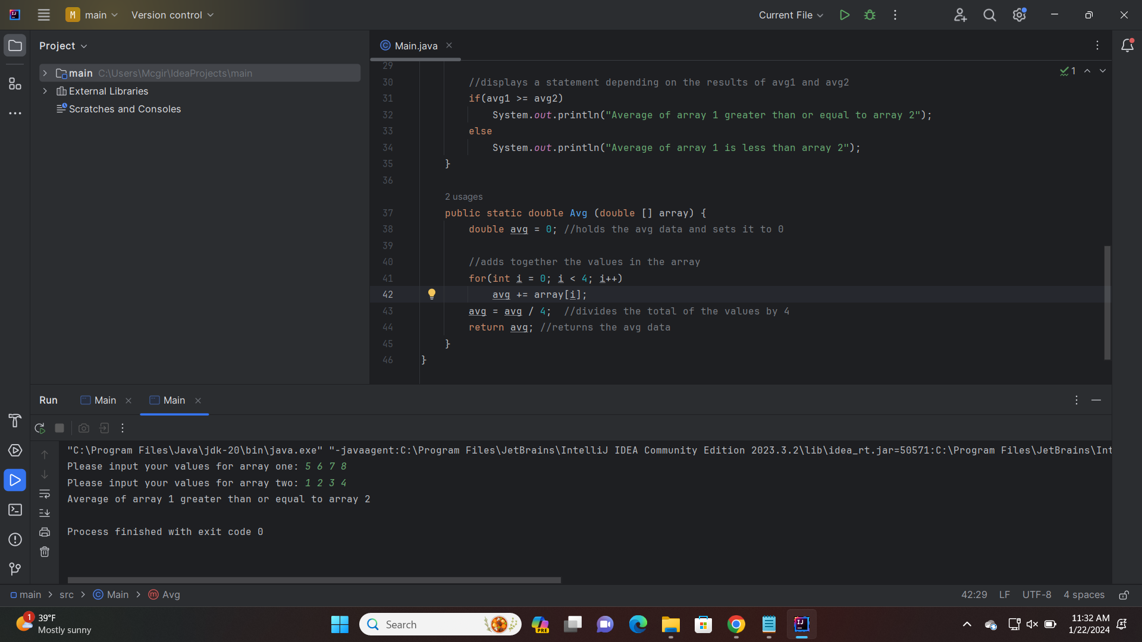

**Question 2: Write a program that will ask the user to enter the size of an integer array. Then the program will prompt the user to enter the values. The program will then use the array to find and print the sum and average.**

//summary: This program takes in an array size. It then makes an array of that size and takes in the

//values for that array. It then finds and dispalys the sum and avg of that array.

//name: Jenna Wolf

//class: Computer Science II, CS-265

//instructor: Mr. Waleed Amer

//date: 01/22/2023

import java.util.Scanner; //allows inputs to be made

public class Main {

public static void main(String[] args) {

Scanner input = new Scanner(System.in); //names the input

int size = 0; //holds the size data and is set to 0

int sum = 0; //holds the sum data and is set to 0

int avg = 0; //holds the avg data and is set to 0

//takes in the size, then declares an array of that size

System.out.print("Enter the size of your array: ");

size = input.nextInt();

int[] array = new int[size];

//takes in the values for the array

System.out.print("Enter your values for the array: ");

for(int i = 0; i < size; i++)

array[i] = input.nextInt();

//finds the sum of the array values

for(int i = 0; i < size; i++)

sum += array[i];

avg = sum / size; //finds the average

//displays the sum and average

System.out.println("sum: " + sum);

System.out.println("average: " + avg);

}

}

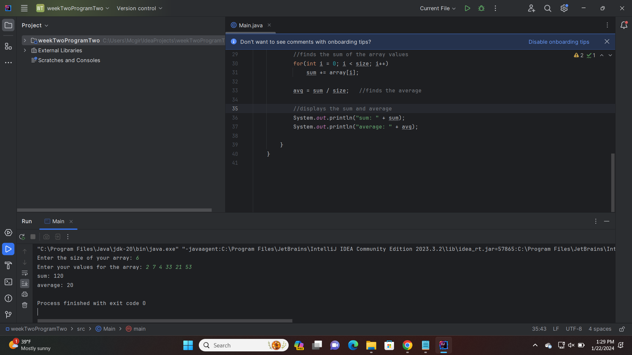

**Question 3: Write a program that creates an array of 10 integers. The program will ask the user to enter the values and then uses the array to find the maximum value stored.**

//summary: This program takes in values for an array of size 10. It then displays the values of the array,

//the max value of the array, and the index of that value

//name: Jenna Wolf

//class: Computer Science II, CS-265

//instructor: Mr. Waleed Amer

//date: 01/22/2023

import java.util.Scanner; //allows inputs to be made

public class Main {

public static void main(String[] args) {

Scanner input = new Scanner(System.in); //names the input

int[] array = new int[10]; //holds the array data (is an array)

//takes in the values of the array from the user

System.out.print("Please enter the values of your array (10 of them): ");

for (int i = 0; i < 10; i++)

array[i] = input.nextInt();

//finds the max value and the index of the max value

int index = 0;

int max = array[0];

for(int i = 1; i < 10; i++) {

if(array[index] < array[i]) {

max = array[i];

index = i;

}

}

//outputs the array values, the max value, and the max value index

System.out.print("Array values: ");

for(int i = 0; i < 10; i++)

System.out.print(array[i] + " ");

System.out.println();

System.out.println("max value: " + max);

System.out.println("max value index: " + (index + 1));

}

}

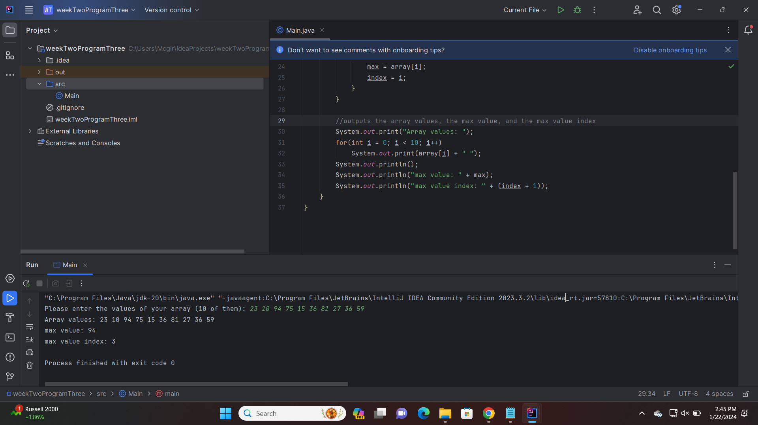

**Question 4: Write a program that will ask the user to enter the following information. Use the linear search algorithm.**

//summary: the program makes an array of whatever size the user wants and takes names to fill that array.

//it then takes in a name from the user and uses a linear search algorithm to see if the name is in

//the array

//name: Jenna Wolf

//class: Computer Science II, CS-265

//instructor: Mr. Waleed Amer

//date: 01/22/2023

import java.util.Scanner;

public class Main {

public static void main(String[] args) {

Scanner input = new Scanner(System.in); //names the input

int size; //holds the size data

//takes in the size and makes an array of that size

System.out.print("how many names are you entering? ");

size = input.nextInt();

String[] names = new String[size];

//takes in the names from the user

System.out.print("Please enter the names: ");

for(int i = 0; i < size; i++)

names[i] = input.next();

//takes in the name the user wants to search for

System.out.print("What name would you like to search for? ");

String name = input.next();

//uses a linear search to see if the name is on the list

boolean found = false;

int index = 0;

for(int i = 0; i < size; i++) {

if(name.equals(names[i])) {

found = true;

index = i;

i = size;

}

}

//outputs the list of names as well as if the name was found or not

System.out.println("list of names: ");

for(int i = 0; i < size; i++)

System.out.print(names[i] + " ");

System.out.println();

if(found)

System.out.println(name + " was found at index " + index);

else

System.out.println(name + " was not found");

}

}

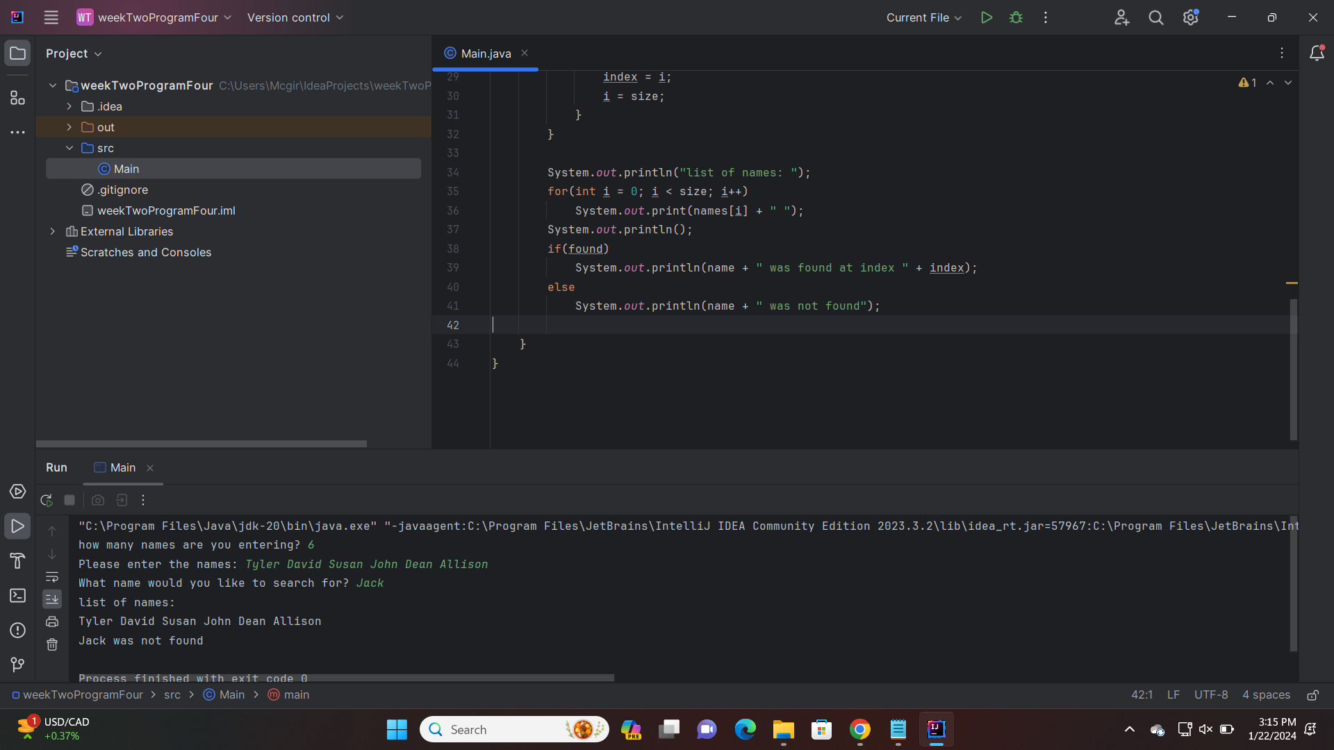

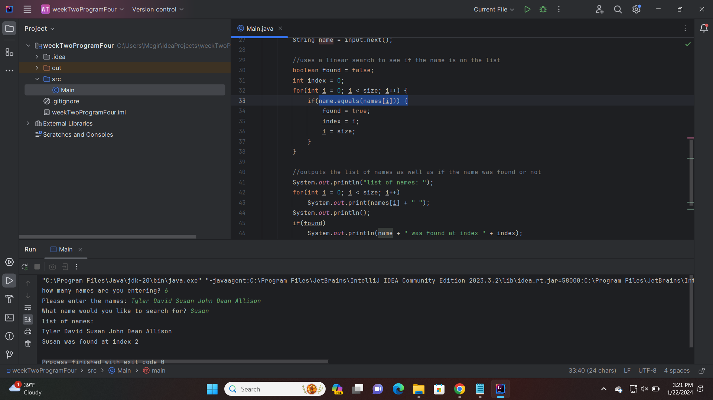

**Question 5: Write a program that will ask the user to enter the following information. Use the binary search algorithm.**

//summary: the program makes an array of whatever size the user wants and takes names to fill that array.

//it then takes in a name from the user and uses a binary search algorithm to see if the

// name is in the array

//name: Jenna Wolf

//class: Computer Science II, CS-265

//instructor: Mr. Waleed Amer

//date: 01/22/2023

import java.util.Scanner;

public class Main {

public static void main(String[] args) {

Scanner input = new Scanner(System.in); //names the input

int size; //holds the size data

//takes in the size and makes an array of that size

System.out.print("how many names are you entering? ");

size = input.nextInt();

String[] names = new String[size];

//takes in the names from the user

System.out.print("Please enter the names: ");

for(int i = 0; i < size; i++)

names[i] = input.next();

//takes in the name the user wants to search for

System.out.print("What name would you like to search for? ");

String name = input.next();

//sorts the array into alphabetical order

String temp;

for(int i = size - 1; i > 0; i--) {

for(int j = 0; j < i; j++) {

if(names[j].charAt(0) > names[j + 1].charAt(0)) {

temp = names[j];

names[j] = names[j + 1];

names[j + 1] = temp;

}

}

}

//uses binary search to see if the name is on the list

int index = 0;

int start = 0;

int end = size - 1;

boolean found = false;

while(start <= end) {

index = (start + end) / 2;

if(name.equals(names[index])) {

found = true;

start = end;

}

if(name.charAt(0) < names[index].charAt(0))

end = index - 1;

else

start = index + 1;

}

//outputs the list of names as well as if the name was found or not

System.out.println("list of names: ");

for(int i = 0; i < size; i++)

System.out.print(names[i] + " ");

System.out.println();

if(found)

System.out.println(name + " was found at index " + index);

else

System.out.println(name + " was not found");

}

}

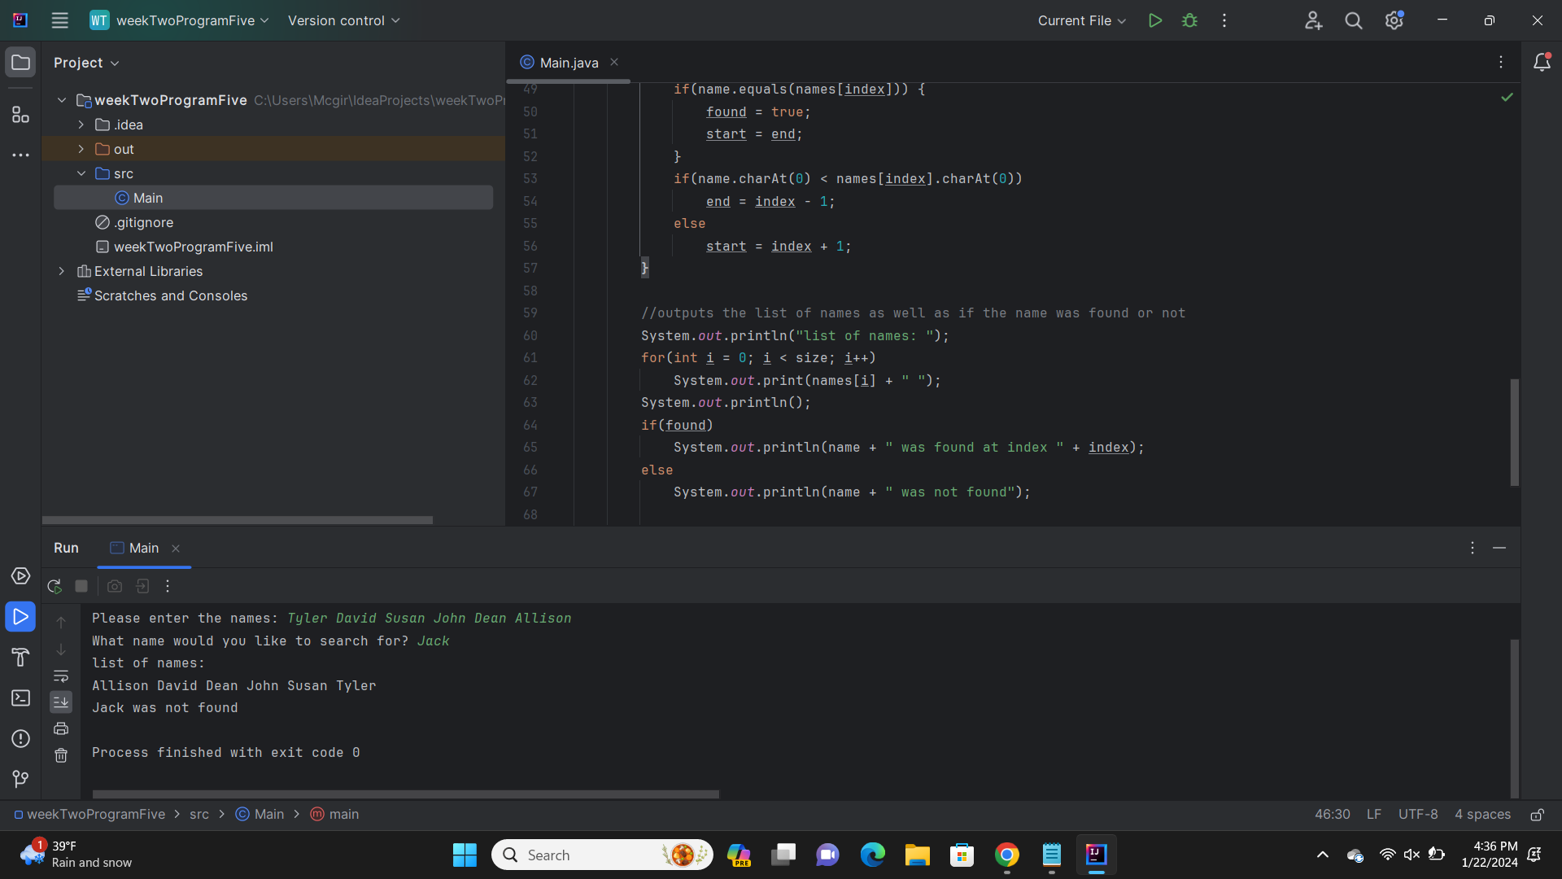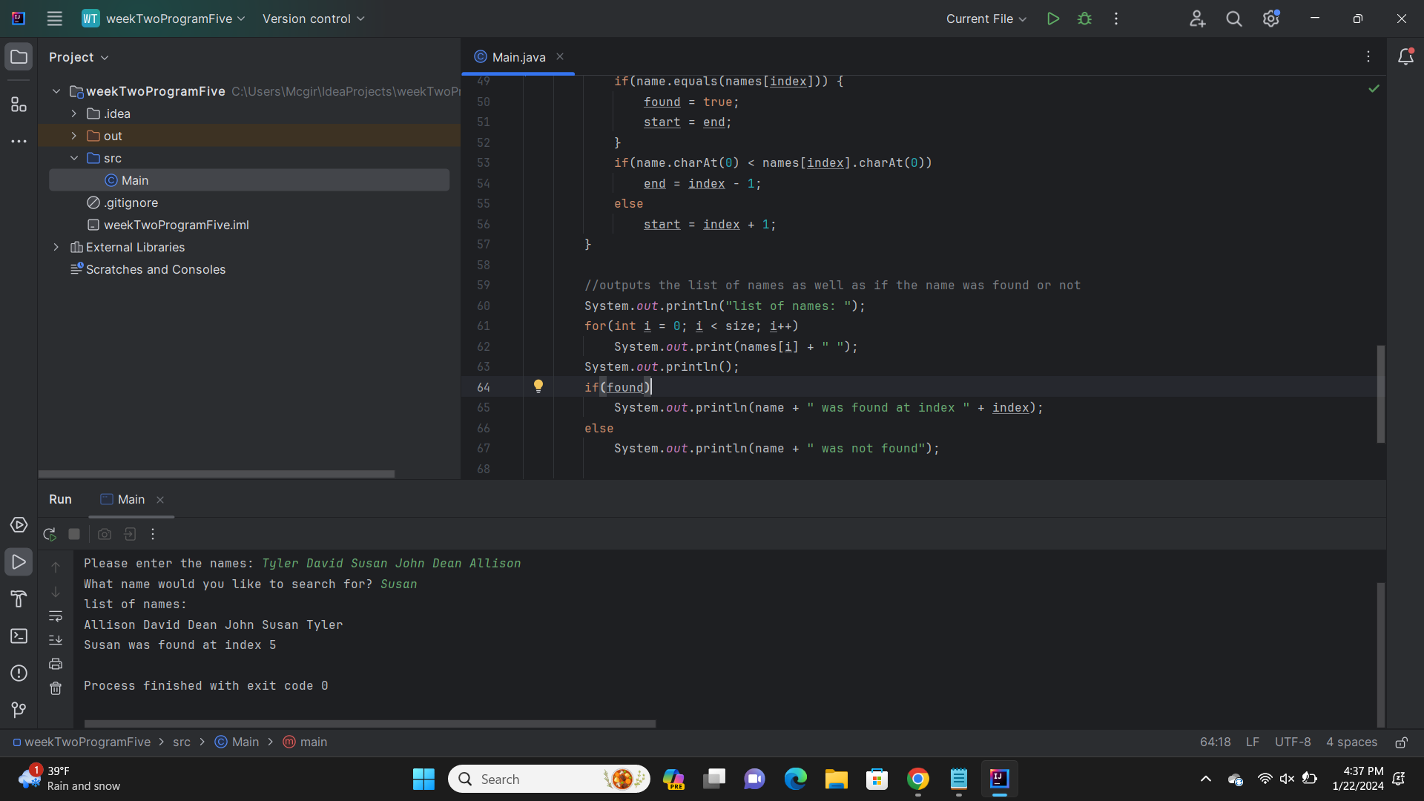

**Question 6: Write a program that will ask the user to enter the following information. Use java.util.Arrays.binarySearch.**

//summary: the program makes an array of whatever size the user wants and takes names to fill that array.

//it then takes in a name from the user and uses a binary search import to see if the

// name is in the array

//name: Jenna Wolf

//class: Computer Science II, CS-265

//instructor: Mr. Waleed Amer

//date: 01/22/2023

import java.util.Scanner;

import java.util.Arrays;

public class Main {

public static void main(String[] args) {

Scanner input = new Scanner(System.in); //names the input

int size; //holds the size data

//takes in the size and makes an array of that size

System.out.print("how many names are you entering? ");

size = input.nextInt();

String[] names = new String[size];

//takes in the names from the user

System.out.print("Please enter the names: ");

for(int i = 0; i < size; i++)

names[i] = input.next();

//takes in the name the user wants to search for

System.out.print("What name would you like to search for? ");

String name = input.next();

//uses the Arrays.sort method to sort the array into order

Arrays.sort(names);

//uses the Arrays.binarySearch method to find the name

int index = Arrays.binarySearch(names, name);

//outputs the list of names as well as if the name was found or not

System.out.println("list of names: ");

for(int i = 0; i < size; i++)

System.out.print(names[i] + " ");

System.out.println();

if(index > 0)

System.out.println(name + " was found at index " + index);

else

System.out.println(name + " was not found");

}

}

